Data Frame in Python
Assignment - 2

- Write a program to create a DataFrame from a list containing dictionaries which contains “Salaries” and “Incentives” for 4 employees. Employee names should be the row labels. Change the index as ‘Raj’,’Aman’,’Rahul’,’Darpan’

- Write code to create DataFrame from a list containing 4 dictionaries, where each dictionary containing Target and Actual Sales figures of four zonal offices. Give appropriate row labels. Change the indexes as –‘Zone 1’,’Zone 2’,’Zone 3’,’Zone 4’

- Given a DataFrame namely “employee” that stores the details of employees:
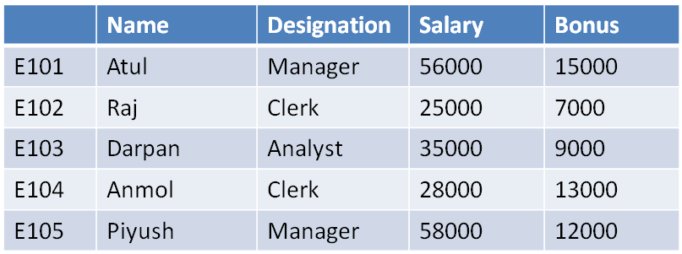
a) Write a statement to display Name, Designation and Salary columns from the above employee DataFrame.
b) Write a statement to display Name and Salary columns from the above DataFrame.

c) Write a statement to display Bonus column only.
d) Write a statement to display all the information from Employee ids ‘E102’ to ‘E104’ (Both are included)
e) Write a statement to display all information of Employee id ‘E102’ and ‘E105’.
f) Write a statement to display the employee’s name, designation and salary for those having employee ids as ‘E101′ and ‘E103’.
g) Write a statement to display the employee’s name and bonus for those having employee id as ‘E101′ and ‘E103’.
h) Write a statement to display the Salary of Darpan.
- Given a DataFrame namely “data”. Write the code for the following commands
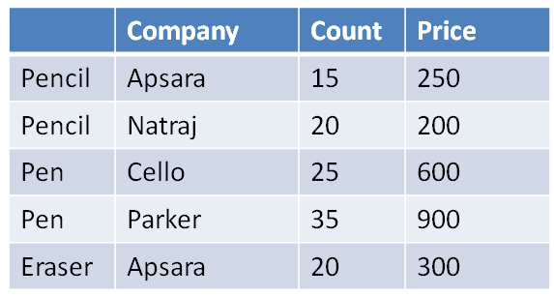
a) Find all rows with the label “Pencil”. Extract all columns
b) List products with count more than 25.
c) List single True or False to signify if all prices are more than 100 or not.
d) List 2nd , 3rd and 4th row.
e) List only the columns Company and Price.
f) List only rows with labels ‘Pencil’ and ‘Pen’
- Tell the output of the following statements. df is the name of the dataframe.
a) df.iloc[:5,]
b) df.iloc[1:5]
c) df.iloc[5,0]
d) df.iloc[1:5,0]
e) df.iloc[1:5,:5]
f) df.iloc[2:7,1:3]
- Trying to extract the first five rows of DataFrame x, Aman has give code as:
x.loc[0:5]
but it is returning 6 rows. Why? Suggest the solution.

- Given a DataFrame namely “employee” that stores the details of employees:
- Add a column called “City” with the following details : [‘Janak Puri’,’Tilak Nagar’, ‘Shiv Nagar’, ‘Vikas Puri’, ‘Janak Puri’]
- Add a column called “Shift” with “Morning” for all the employees.
- Add a new row with the following details : [‘E106’, ‘Keerat’, ‘Analyst’, 70000, 15000, ‘Tilak Nagar’, ‘Morning’].
- Delete column “Shift” from the above dataframe employee.
- Delete the record with employee id ‘E103’ and ‘E105’.
- Rename column “Bonus” as “Incentive”.

- Given a DataFrame namely “data”. Write the code for the following commands
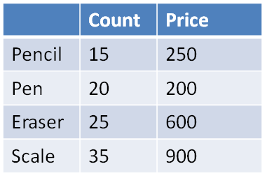
a) Change the Eraser count as 15 instead of 25.
b) Rename the index “Scale” as “Wooden Scale”.
c) Change all the row label as ‘Product 1′, Product 2’, ‘Product 3’, ‘Product 4’.
d) Change all the column name as ‘Discount’, ‘Total’
e) Add a new row ‘Product 5’ with value 10 and 100.
- Question : From the above dataframe ‘data’, create another dataframe ‘Products’ and it must not contain the column ‘Total’. In the above dataframe ‘data’, add an empty column ‘Stock’.
- Write the commands for the following statement after analysis the given dataframe ‘batsman’. 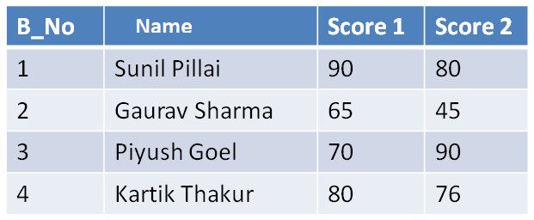
a) Add both the scores of a batsman and assign to column “Total”.
b) Display the highest score in both Score 1 and Score 2 of the DataFrame.
c) Display the DataFrame.
- Consider the following dataframe “Employee” and answers the following questions :
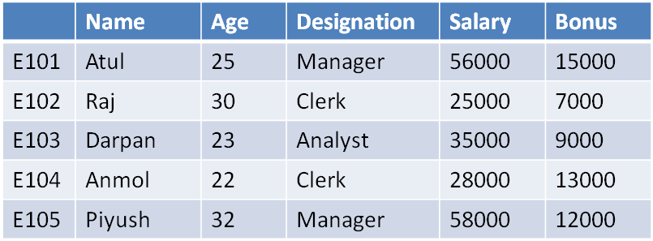
a) Print the details of youngest employee.
b) Print the details of all clerk from the employee.
c) Print the average Bonus.
d) Print the total salary distributed among the employees.
- Consider the following dataframe “Items” storing production in tones and answers the following questions :
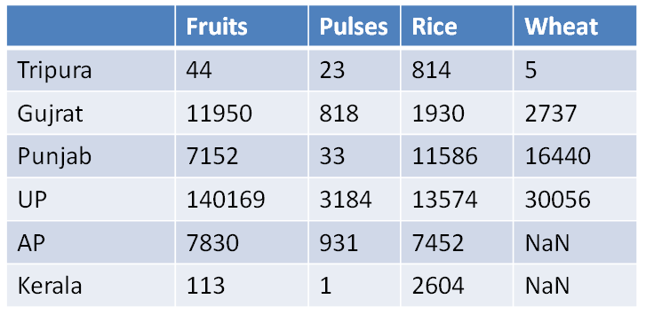
a) Total production for each state.
b) Total production for each item type.
c) How many States produces Wheat?
d) Print details of the state with maximum Rice production.
- Given a DataFrame namely “employee” that stores the details of employees:
a) Display the row labels of employees
b) Display the columns labels of employees
c) Display the data types of each columns of employees
d) Find the dimensions of the employee dataframe.
e) Find number of rows and columns of employee dataframe.
f) Find total numbers of rows and columns of employee dataframe.
g) How can you see all values of dataframe employee with the help of attributes?
h) Find number of rows and number of columns in employee without using shape attribute.
i) Check employee dataframe is empty or not.
- Consider the following dataframe “Details” and answers the following questions
a) Display first 3 rows of “details” dataframe using appropriate function.
b) Display last 4 rows of “details” dataframe using appropriate functions.
c) Display the DataFrame by sorting in ascending order based on the ‘Name’ column.
d) Display the DataFrame by sorting in descending order based on the ‘Age’ column.
e) Display the DataFrame by sorting in descending order based on the indexes/row label.

